William Shanks 709 digits PI

Everyone will tell you that that William Shanks calculated 707 digits of PI and you can tell them that they are wrong. He calculated 709 digits of PI but only published 707 digits by dropping the last two digits. On most published values the last 2 digits are written as “85+”.The “+” I thought it meant that there are more digits to be calculated which I was correct except most likely he was referring to the two dropped digits which have the value of 92. I have not been able to fine any T-shirt with the value of PI from William Shanks on it with or without the two extra digits. Well here make your own for the fun of it and start up a conversation with some math enthusiast who thinks they know all about William Shanks.

The first pattern comes from a Greek alphabet that I have. The second one looks closer to what most regular PI symbol, remember there are fewer digits than the normal PI symbol used on a normal PI T-shirt. There are two pages reversed and set up printing T-shirts, one in blue the other in black.

This file is a PDF format, on the same web location I have also stored the MS Word format DOC not the DOCX format just change the extension from PDF to DOC and you can have the word format to make your own symbol but remember there are only have 712 symbols to work with not 1000’s.

The last page has the raw data for you to make your own work T-shit image.

Williams Shanks 709 digits of PI

3.1415926535897932384626433832795028841971693993751058209
74944592307816406286208998628034825342117067982148086513
82306647093844609550582231725359408128481117450284102701
93852110555964462294895493038196442881097566593344612847
5648 2337867831 6527120190
914 5648566923 4603486104
54 3266482133 9360726024
9 1412737245 8700660631
5588174881 5209209628
2925409171 5364367892
5903600113 3053054882
0466521384 1469519415
1160943305 7270365759
5919530921 8611738193
2611793105 1185480744
6237996274 9567351885
7527248912 2793818301
1949129833 6733624406
5664308602 1395016092
4 480772309 436285530 9
66 20275569 39798695 02
224 7499620 6074970 304
1236 688619 951100 8920
23837 70213 14169 41190
298858 2544 6816 397999
046597000 817002963
12377381 3420841
307914 511839
805709 85+ 92
Williams Shanks 709 digits of PI

3.1415926535897932384626433832795028841971693993751058209
74944592307816406286208998628034825342117067982148086513
82306647093844609550582231725359408128481117450284102701
93852110555964462294895493038196442881097566593344612847
5648 2337867831 6527120190
914 5648566923 4603486104
54 3266482133 9360726024
9 1412737245 8700660631
5588174881 5209209628
2925409171 5364367892
5903600113 3053054882
0466521384 1469519415
1160943305 7270365759
5919530921 8611738193
2611793105 1185480744
6237996274 9567351885
7527248912 2793818301
1949129833 6733624406
5664308602 1395016092
4480772309 436285530 9
662027556939 79869502 22
474996206074 97030412 366
88619951100892 02383770 2131
416941190298858 254468163
9799904659700081 7002963
12377381342084130 791451
183980570985+ 92
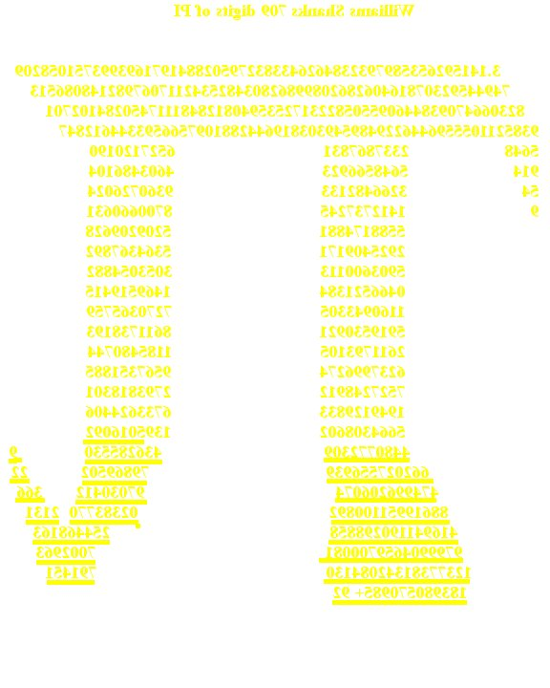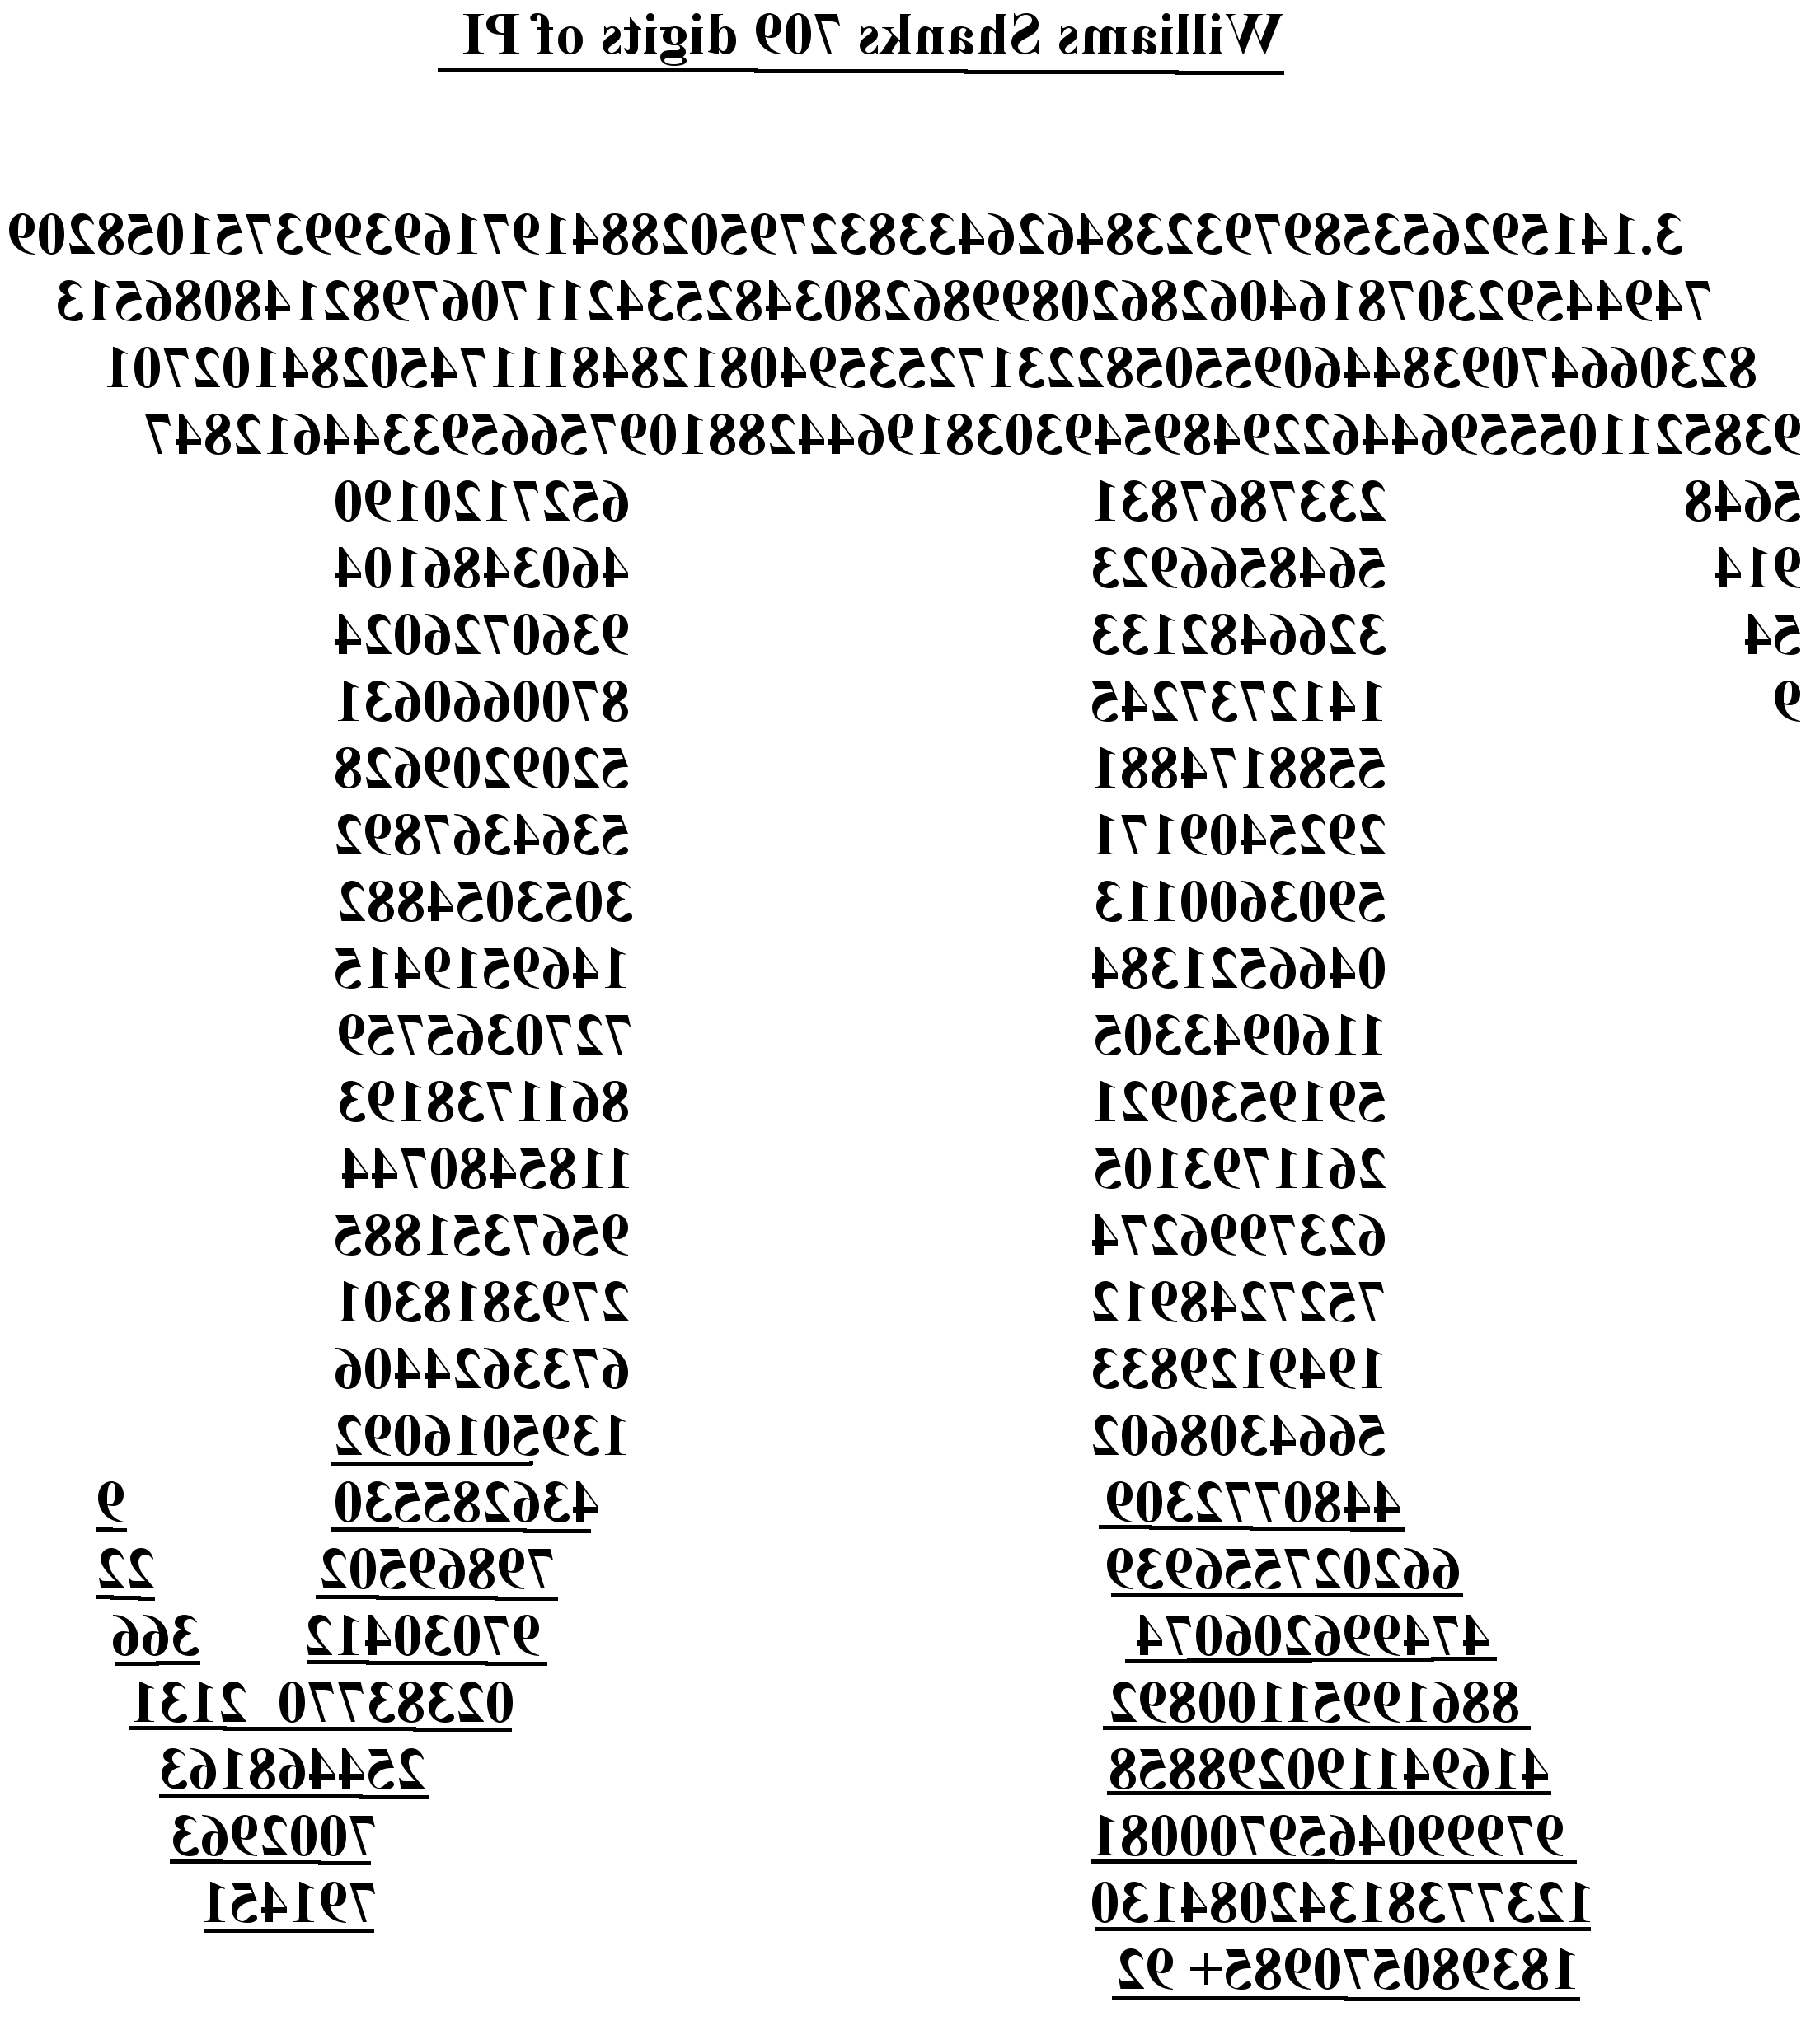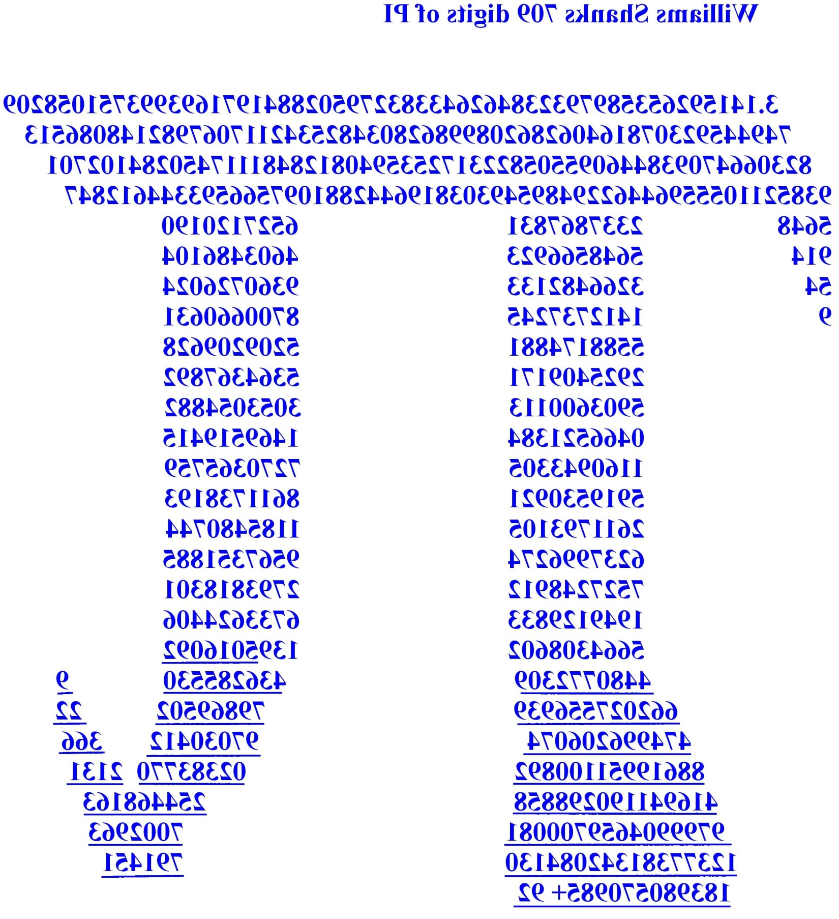
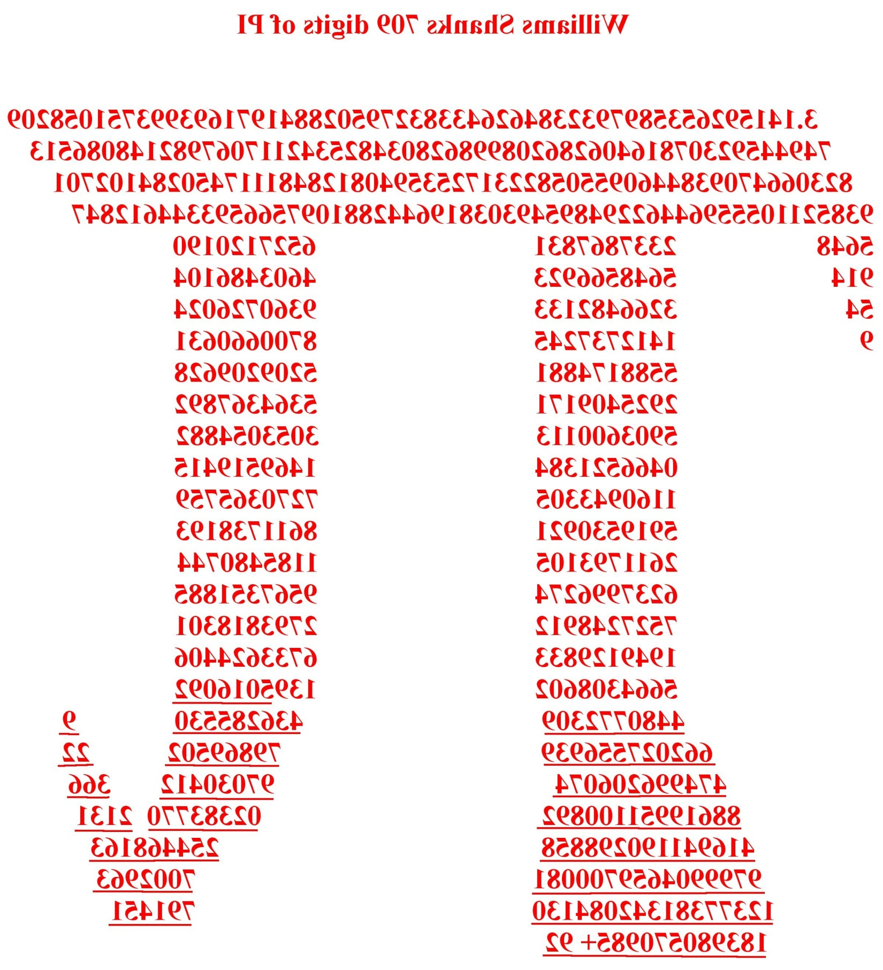
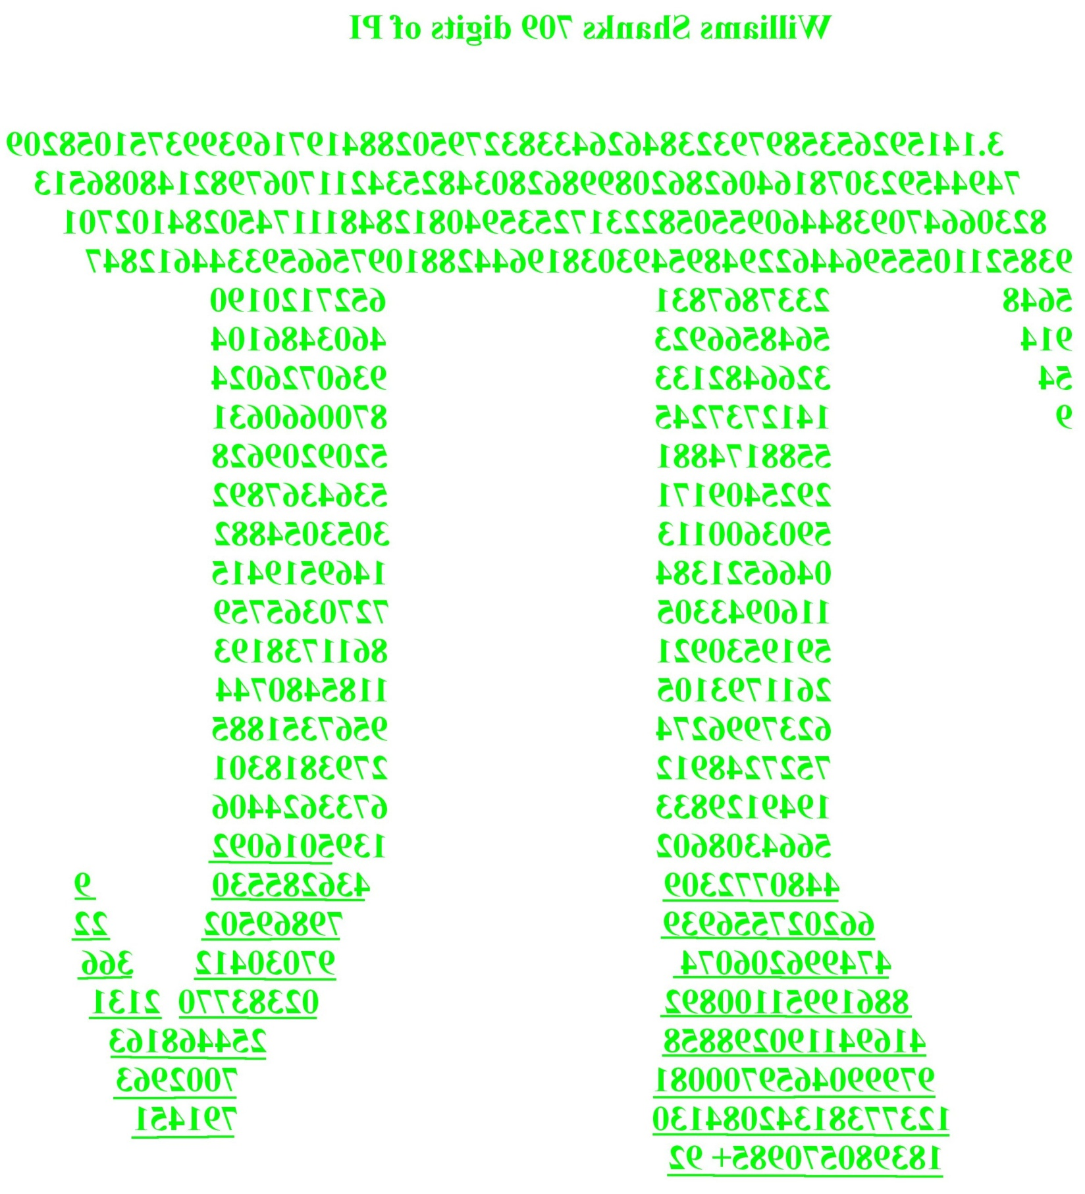
3.
14159 26535 89793 23846 26433 83279 50288 41971 69399
37510 58209 74944 59230 78164 06286 20899 86280 34825
34211 70679 82148 08651 32823 06647 09384 46095 50582
23172 53594 08128 48111 74502 84102 70193 85211 05559
64462 29489 54930 38196 44288 10975 66593 34461 28475
64823 37867 83165 27120 19091 45648 56692 34603 48610
45432 66482 13393 60726 02491 41273 72458 70066 06315
58817 48815 20920 96282 92540 91715 36436 78925 90360
01133 05305 48820 46652 13841 46951 94151 16094 33057
27036 57595 91953 09218 61173 81932 61179 31051 18548
07446 23799 62749 56735 18857 52724 89122 79381 83011
94912 98336 73362 44065 66430 86021 39501 60924 48077
23094 36285 53096 62027 55693 97986 95022 24749 96206
07497 03041 23668 86199 51100 89202 38377 02131 41694
11902 98858 25446 81639 79990 46597 00081 70029 63123
77381 34208 41307 91451 18398 05709 85+

If you want to add the two missing digits they are 92.

